US Cellular

Remote Engine upgrade for Talend 8.0

Document Information
This document provides the details with respect to talend remote engine upgrade to v2.13.4 and java17 installation.
Servers upgraded to Remote Engine 2.13.4:-
- ilscha03-cem-dev-pre3.cem.uscc.com
- sdr01infa1
- sdr02infa1

- Login to the server using your lan id and password
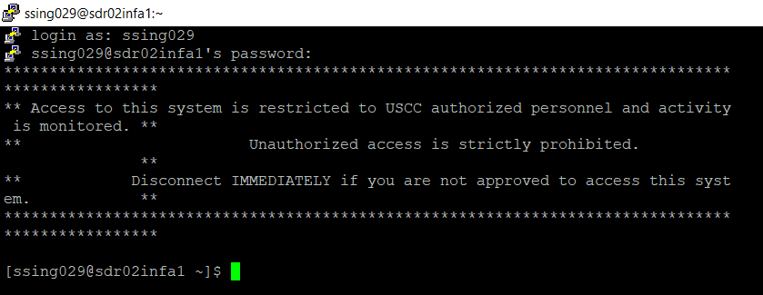

- Login using services account: sudo su – svc_talend
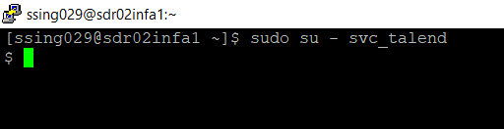
- Copy the following (see below) to /home/svc_talend/
1. zulu17.48.15-ca-jdk17.0.10-linux_x64.zip
2. Talend-RemoteEngine-V2.13.4-269.tar.gz
- Stop the services using below command from path /home/svc_talend/re/bin
./stop
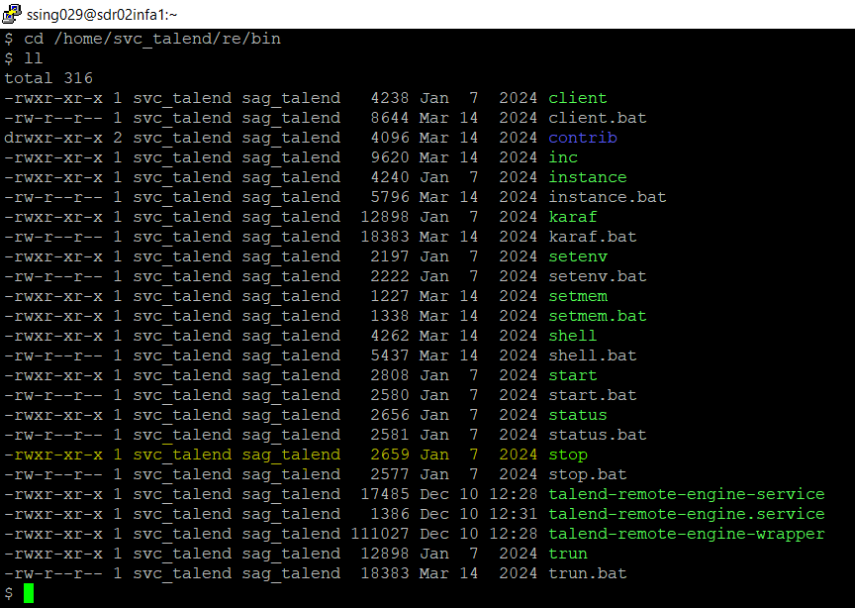

JAVA17 installation steps:
- Create a java17 folder at path /home/svc_talend and unzip the file zulu17.48.15-ca-jdk17.0.10-linux_x64.zip at same path

- Edit the .profile file present at path /home/svc_talend update the JAVA_HOME variable to /home/svc_talend/java17
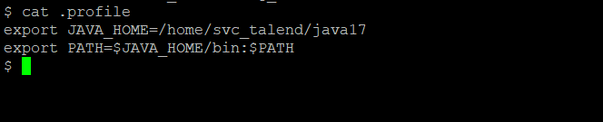

- Source the .profile and check if the change is reflecting
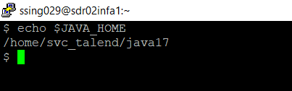

Talend Remote Engine upgrade to version 2.13.4 steps:
- Go to Talend folder: cd /home/svc_talend
- Take backup of ‘re’ folder using current date: mv re re_12102024
- Check if copy created: ls -ltr
- In path ‘cd/home/svc_talend’ : tar -xvzf /home/svc_talend/ Talend-RemoteEngine-V2.13.4-269.tar.gz
This will create file Talend-RemoteEngine-V2.13.4
- Rename ‘Talend-RemoteEngine-V2.13.4’ to ‘re’
mv Talend-RemoteEngine-V2.13.4 re
- Go to ‘cd /home/svc_talend/re/etc’
- ls -ltr
- Open TMC at this point.
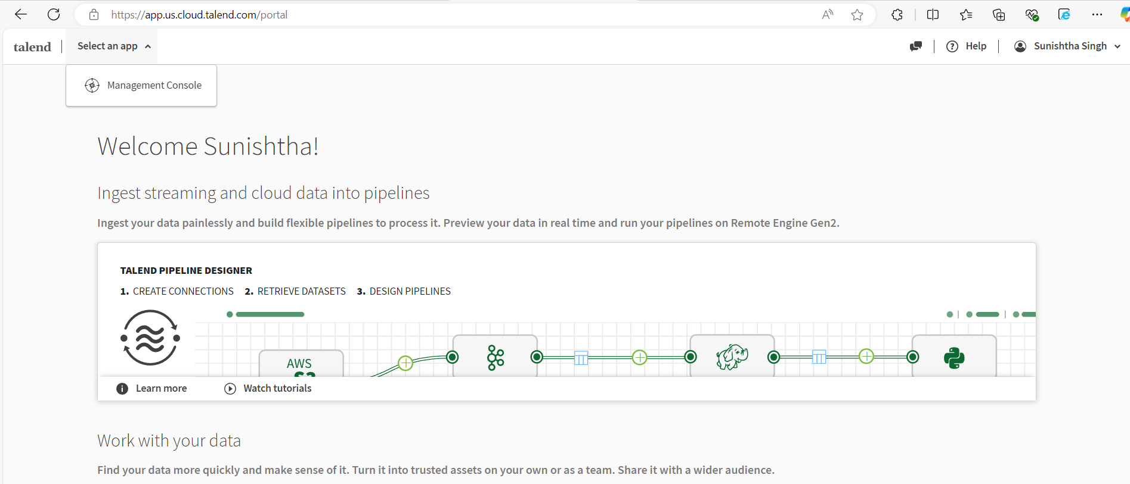

- Go to Processing in the left panel and select isdev environment
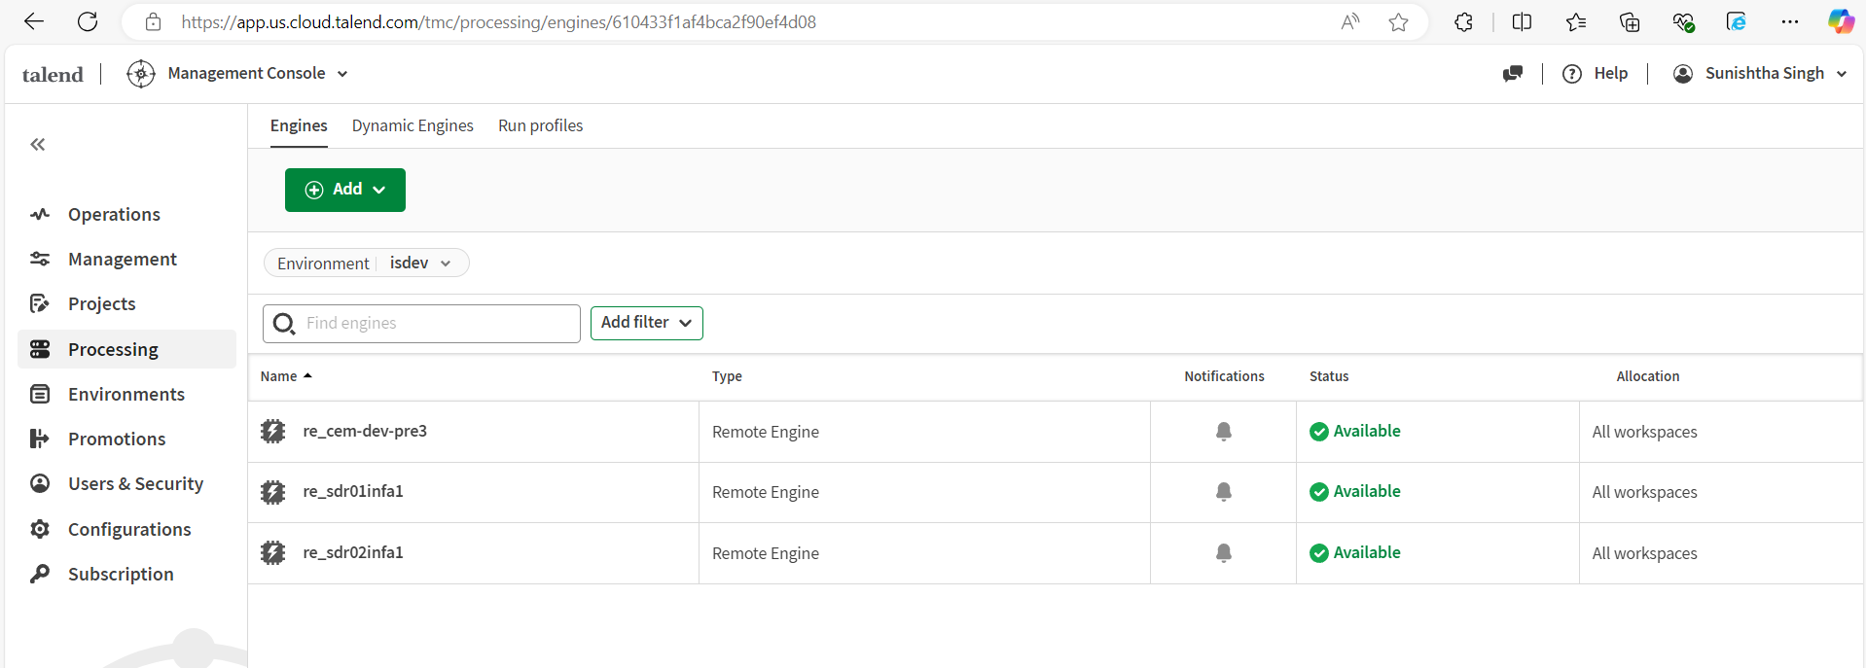
- Select the engine. Click on Manage and click on button “Generate Key”, copy the key.
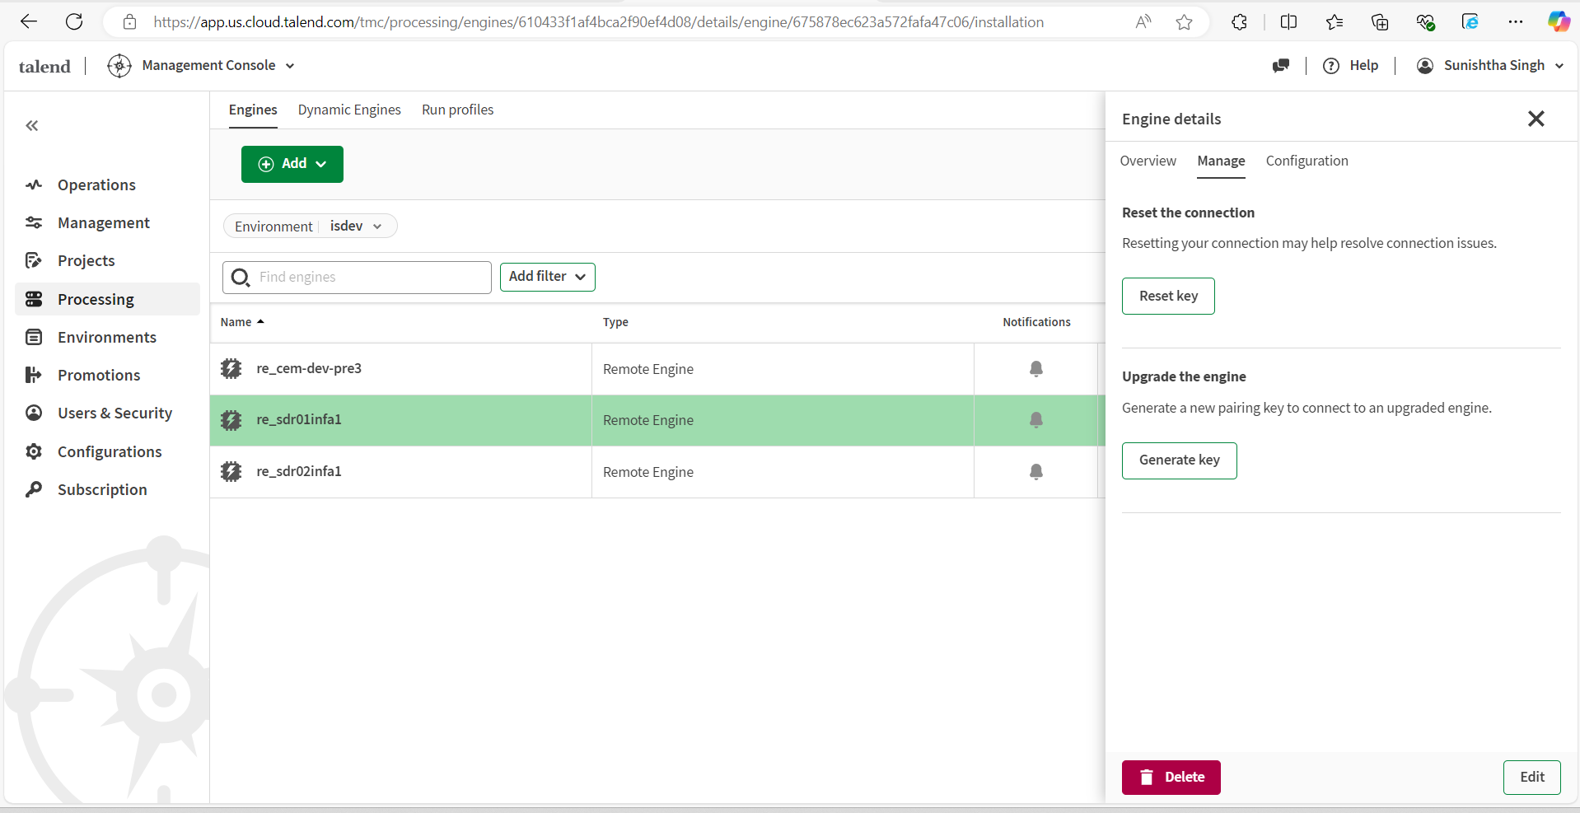
- Copy the key to servers on path /home/svc_talend/re/etc/preauthorized.key.cfg file
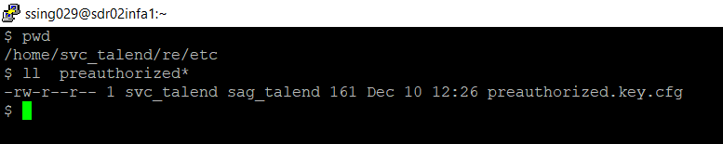

- vi preauthorized.key.cfg
- Put copied key: remote.engine.pre.authorized.key=”put key here”
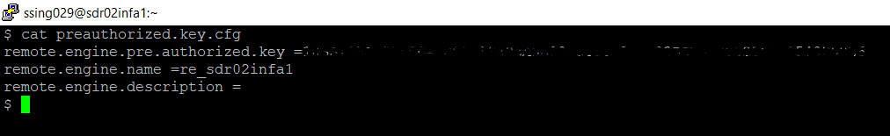
- Save and quit vi mode
- To start engine, go to: cd /home/svc_talend /re/bin
- and run trun with command: ./trun
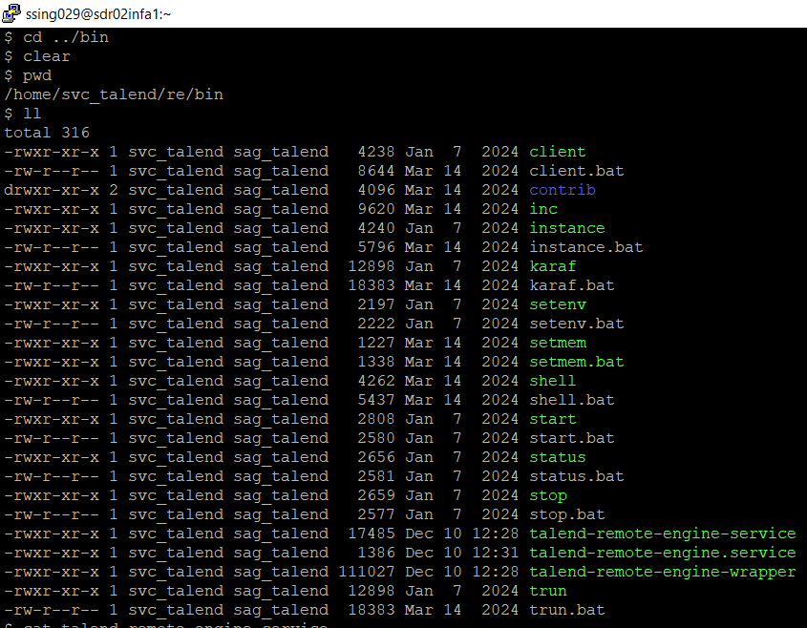
- You will get a karaf prompt.
- Run the command “list”. All the services should be resolved or Activated.
- List all the bundles in RE using command bundle:list
- Check the status for jna bundle using command bundle:list | grep jna
- If the status of jna bundle is in unresolved state restart it using the command bundle:restart jna
- Go to path /home/svc_talend/re/etc and add below properties in system.properties file
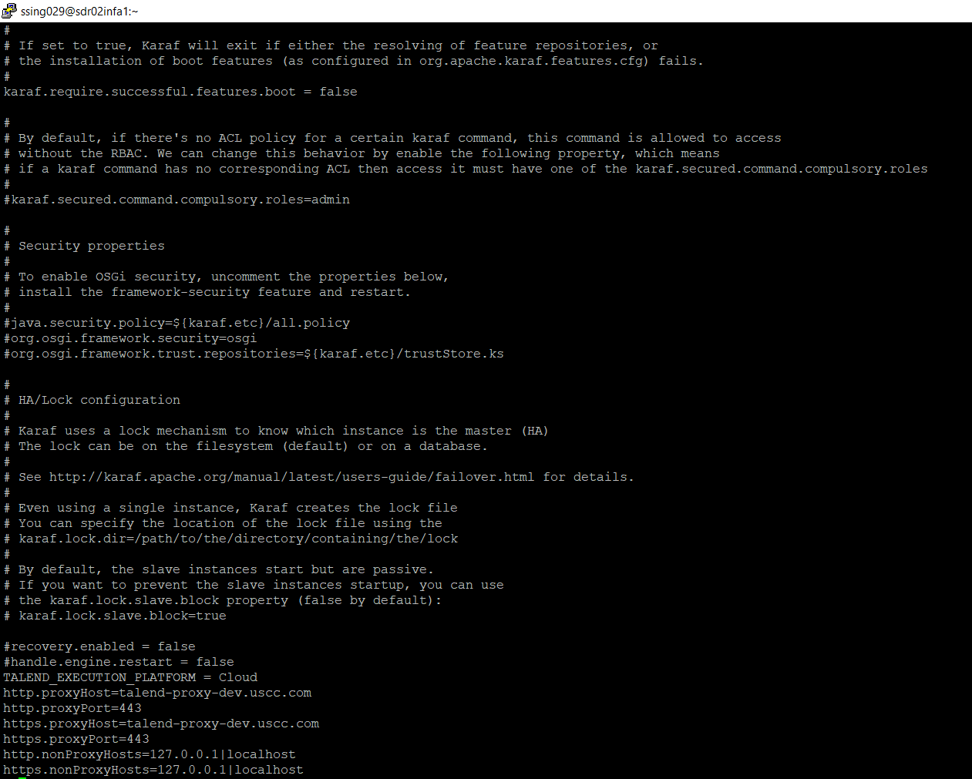

- Go to TMC at this point to confirm that remote engine has repaired and is up
- Come back to server.
- Now we will install services
- At the karaf prompt, run: feature:install wrapper
- At karaf prompt, run: wrapper:install -n talend-remote-engine
This creates lot of files.
- Do a Control D which means we are shutting down the karaf. Karaf is a Java process.
- Do a ‘pwd’ to make sure you are in the path: ‘/home/svc_talend/re/bin’
- Do a ls-ltr
- 3 service files will be created in this path:
-rwxr-xr-x. 1 svc_talend sag_talend 17463 Mar 7 11:29 talend-remote-engine-service
-rwxr-xr-x. 1 svc_talend sag_talend 1336 Mar 7 11:29 talend-remote-engine.service
-rwxr-xr-x. 1 svc_talend sag_talend 111027 Mar 7 11:29 talend-remote-engine-wrapper
32. Open the .service file using command: vi talend-remote-engine.service.
33.Add below lines under the ‘Service’ section: (We are enforcing that if you are starting the service,use this user and group and not root.). By default it starts with root.
User=svc_talend
Group=sag_talend
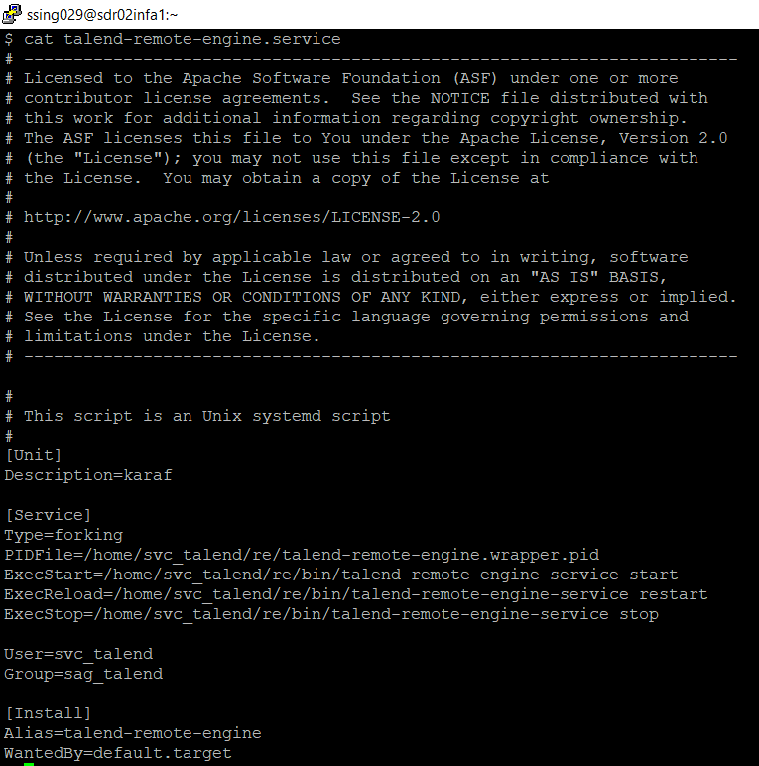
34. Save and quit.
35. We can check the memory in etc.
Go to talend-remote-engine-wrapper.conf
cat talend-remote-engine-wrapper.conf
We can confirm under section ‘Maximum Java Heap Size(in MB): wrapper.java.maxmemory=1024

This concludes our Remote Engine Installation.
Start the services using below command:
cd /home/svc_talend/re/bin
./start

